Net Solutions Web

By

_________

Level-6

Final Project

Table of Contents

Project Proposal 3

Goals and Objectives 3

Project Scope 3

Project Specifications 3

Target Audience 3

Project Deliverables 4

Resource Requirements 4

Project Tasks and Milestones 4

Project Assumptions 5

Project Report 5

Detail Design 6

Home Page 6

Testimonial Admin View 6

Career Admin View 7

Stories Admin View 7

Testimonials Page View 8

Success Stories Page View 8

Career Page View 9

Contact Us Page View 9

Project Testing 10

User Manual 10

Summary 10

System Configuration 10

User Access Levels 10

# 

# Project Proposal

## Goals and Objectives

Net Solutions is a strategic design & build consultancy that unites creative design thinking with agile software development under one expert roof. The main goal of ‘Net Solutions Web’ is to provide a global presence where they showcase their work and attract more client. In this web application, we implement the concept of authentication as well as authorized view of content. Here, admin has full authority to maintain content of web application which will be display to all visitor of this web application. Registered user is capable to send their quote for their requirement. Job seeker has a career section, where they can upload their resume.

## Project Scope

The scope of this project is to implement an app named “Net Solutions Web”, with the help of this web application, we can make their global presence. The duration of the project is 20 working days which is equals to 4 weeks.

## Project Specifications

* Admin login/logout
* Add, edit, delete and check content details of web application.
* Admin can register new admins.
* Registered User can login/logout.
* New Visitor can register.
* Registered User capable to send their quote of requirement.
* Visitor can submit their resume online from this web application.

## Target Audience

The target audience for this project is the people who want to take the software services online. The age can go from 18 plus to 100 plus.

## Project Deliverables

The deliverables of the project are:

|  |  |
| --- | --- |
| Deliverable | Description |
| Final Report | This will be the final report of the project. |
| Coding | The executable code of the project will go under this. |
| Documentation | This portrays the documentation of the project. |
| Testing | All the test details will be covered in this part. |

## Resource Requirements

* Windows Operating System.
* Microsoft word for documentation.
* Asp.net MVC Framework
* 64-bit Processor and 4 GB or more RAM
* Identity framework- ASP

## Project Tasks and Milestones

|  |  |  |  |  |
| --- | --- | --- | --- | --- |
| **Tasks** | **Week-1** | **Week-2** | **Week-3** | **Week-4** |
| Brainstorming and analysis |  |  |  |  |
| Planning and initial meeting Project Proposal document. |  |  |  |  |
| Database Design and UI Design |  |  |  |  |
| Identity framework implementation |  |  |  |  |
| Coding for admin and reporter |  |  |  |  |
| Testing |  |  |  |  |
| Final Documentation and closing |  |  |  |  |

## Project Assumptions

Following are the assumption made while implementing the project:

* One admin and one registered user will be registered by default.
* Application will be free and open source.

# Project Report

#### Functional and Non-Functional

|  |  |
| --- | --- |
| Users | Functional |
| Admin | * Login/logout * Register new admins * Admin can add, edit, delete, check content details of web applications. * Admin can view the submitted quote by registered user. * Admin can view the submitted resume of interested job seeker. |
| Registered User | * Can visit the web site and explore the company details. * Registered user capable to send their quote for requirement of any kind of software services * Visitor are capable to send their resume to company directly. * New customers can register for free. * Login using valid credentials |
|  | Non- Functional |
|  | * High speed * Fast Loading time * High performance and security * All browsers compatibility. |

## Detail Design

### Home Page

The main landing page of the application. From this web page visitor can explore the Net Solutions Web.

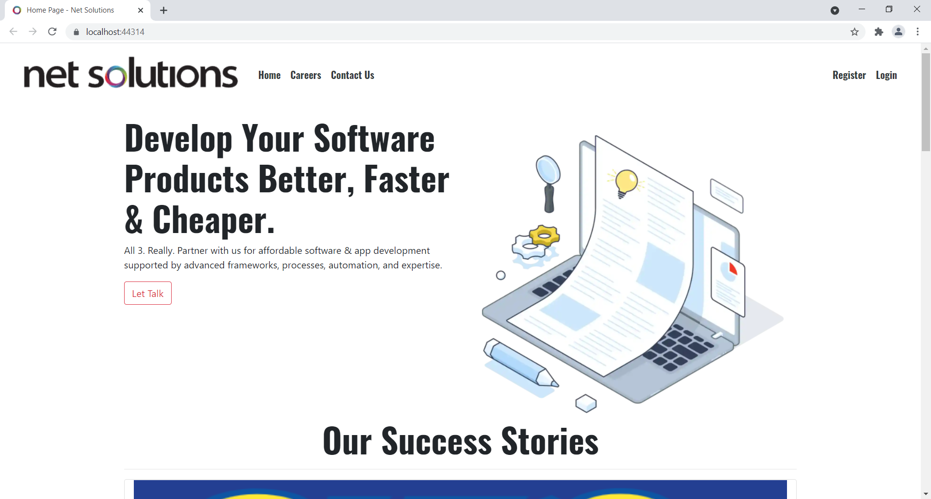

### Testimonial Admin View

From this view, Admin can view all testimonial and control its information.

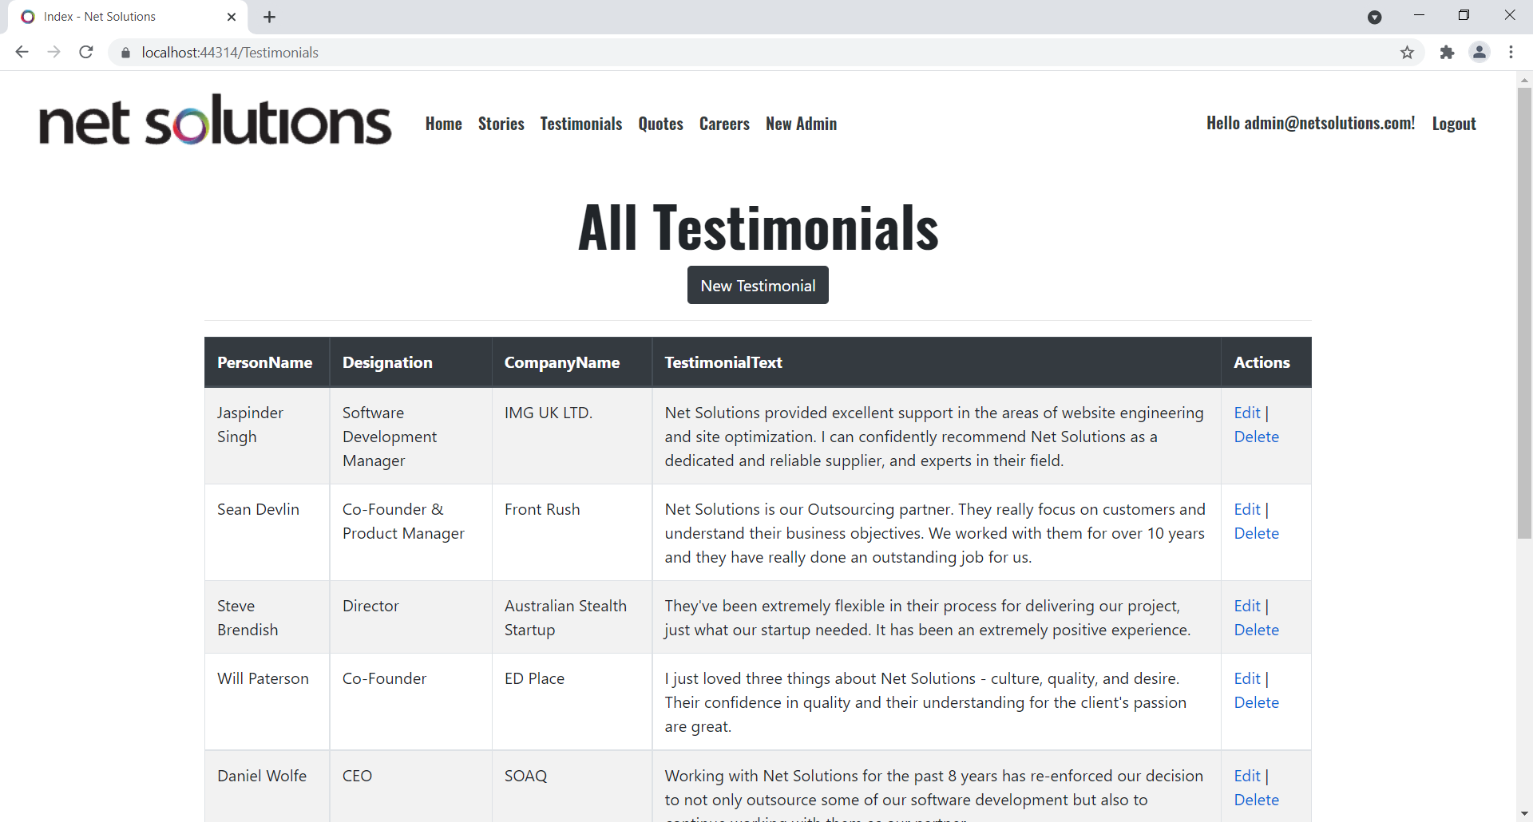

### Career Admin View

This view display all requested resume send by interested job seeker.

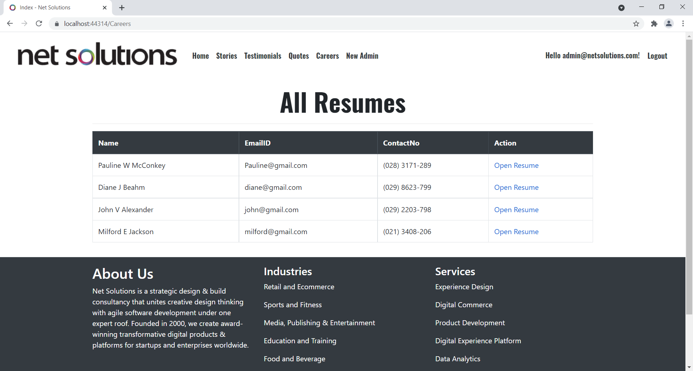

Stories Admin View

This view show all success stories of Net Solutions and admin has authority to control them.

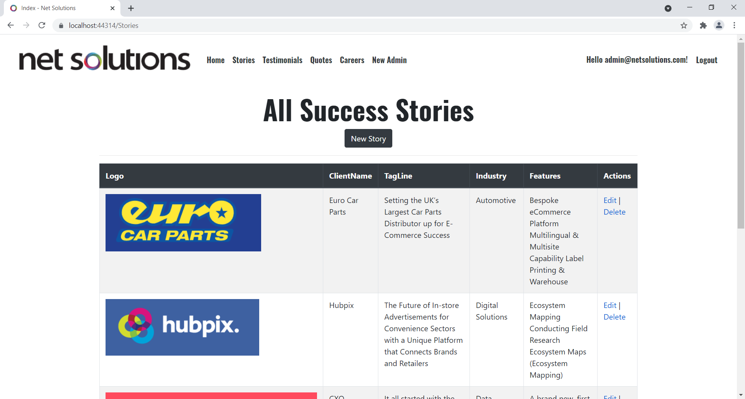

### Testimonial Page View

This view for visitor as well as registered user for all testimonial of Net Solutions company.

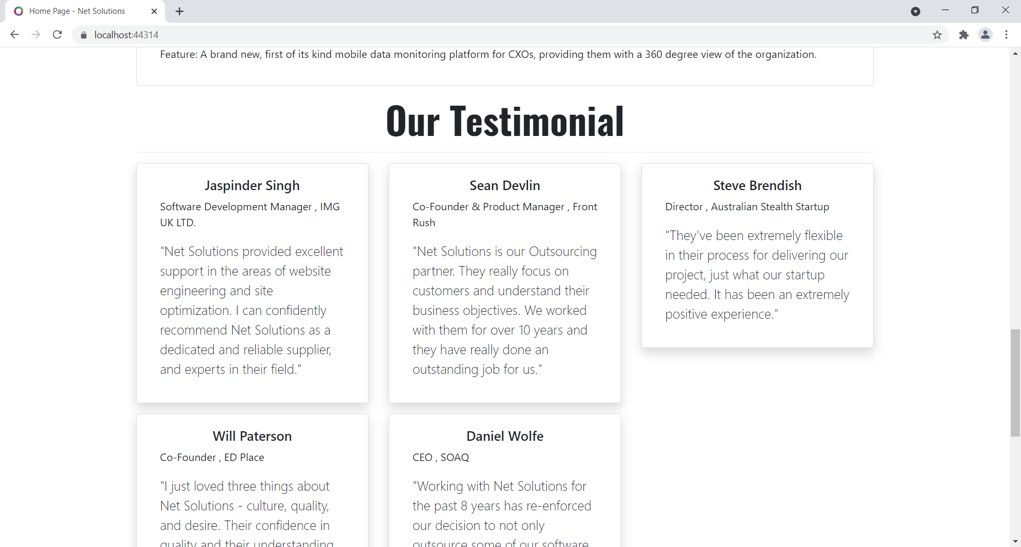

Success Stories Page View

This view display all success stories to visitor as well as registered users.

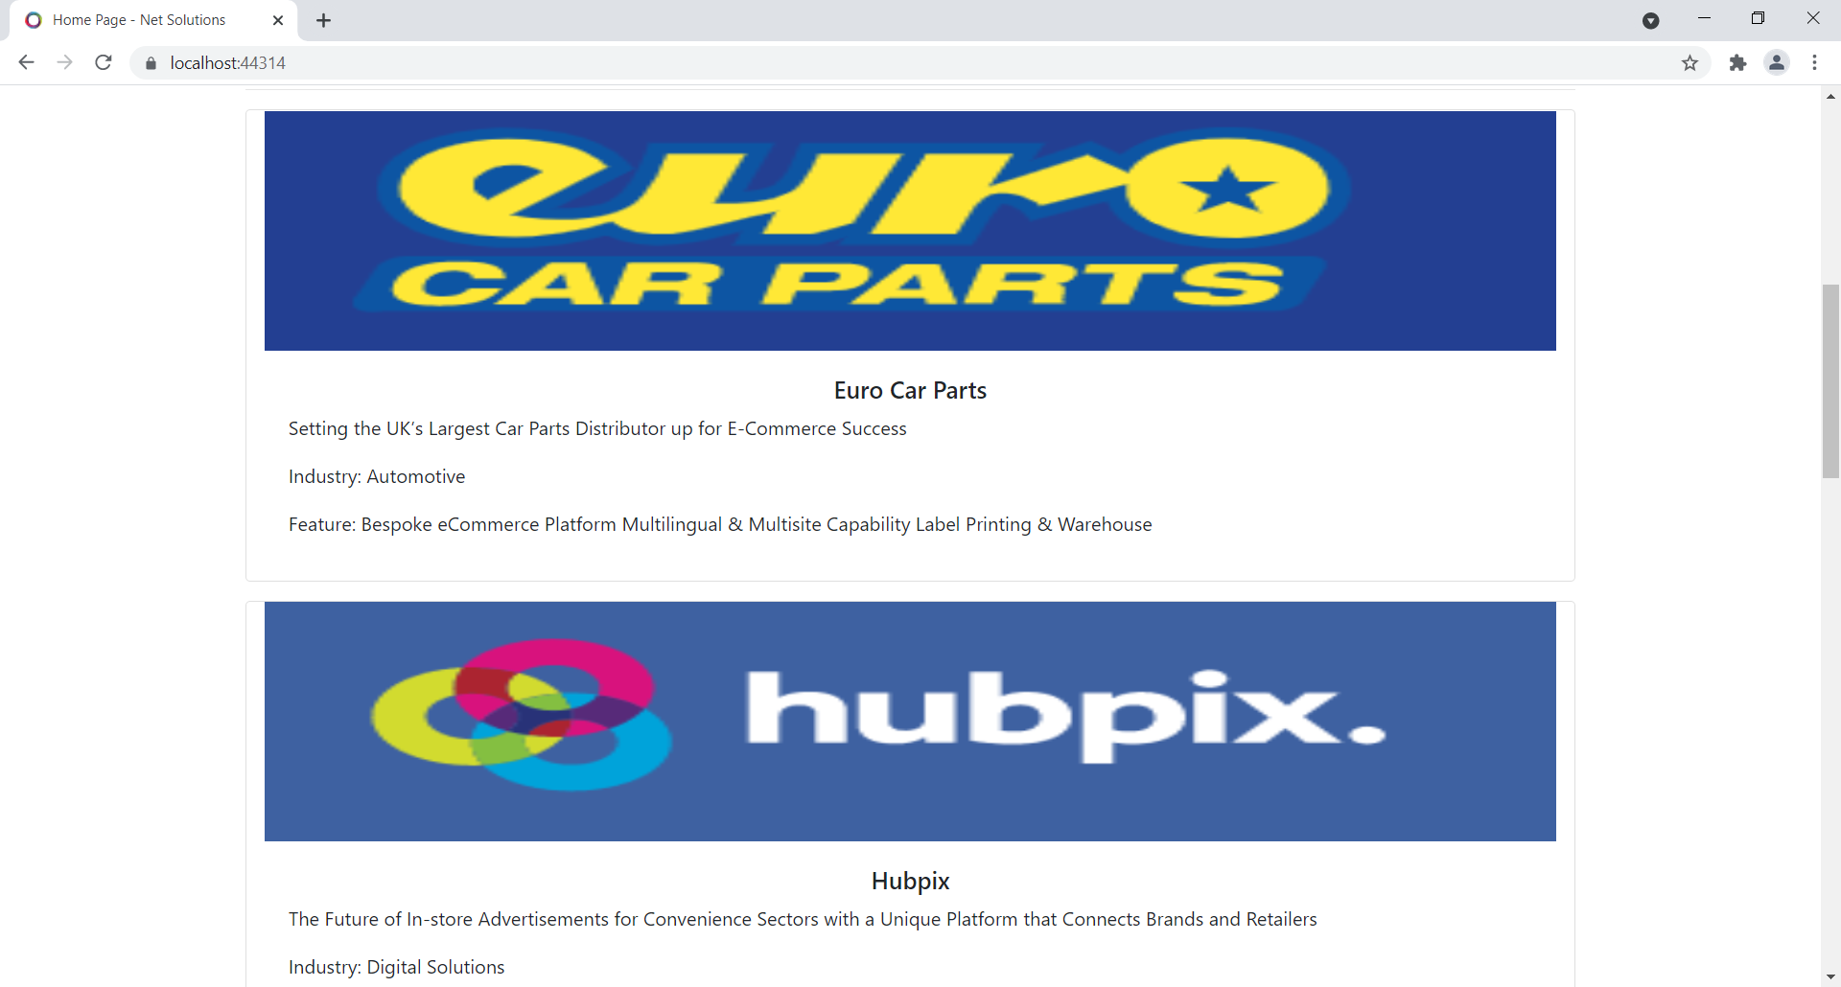

Career Page View

This view for collecting job seeker resume and personal details.

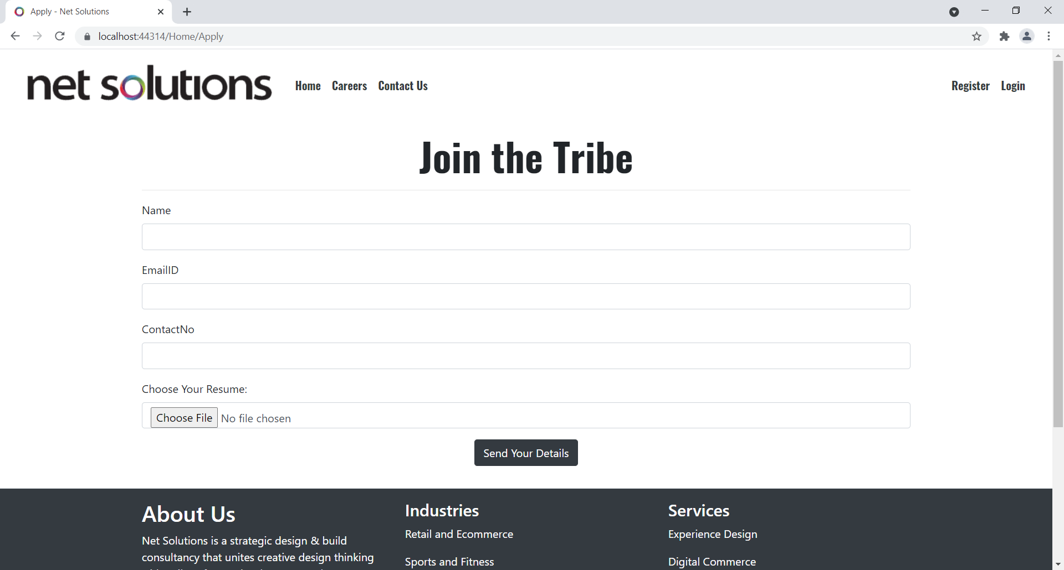

Contact us Page View

This view for collecting registered user quotes for requirement.

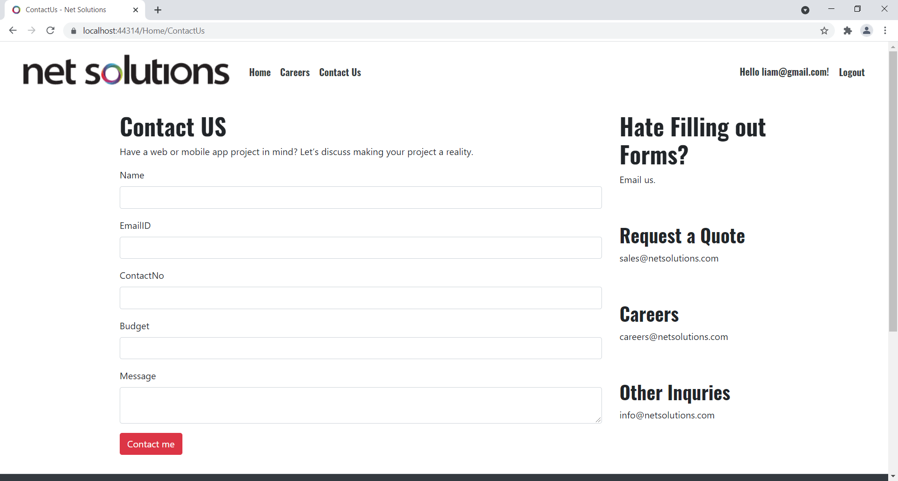

## Project Testing

The testing file for usability testing is attached as [usability test.xlsx](usability%20test.xlsx)

# User Manual

The main purpose of the application Net Solutions Web is to provide a global presence to Net Solutions Company which provide software services solutions to their client. In this application there are two types of users- admin and registered user or visitor. Admin has different functionalities as compare to registered user. Admin can add, edit, delete and check content details of Net Solutions Company Registered User is capable to send their requirement quote to company authorities.

## Summary

### System Configuration

This app will be useful to for distributing mobile information in presentable format.

### User Access Levels

Only registered users can access the features of this application.

* **Admin:** Admin has full access of the app can register new admins.
* **Registered Visitor:** New visitor can register and existing can login using their own credentials. They have limited access.